
[Learner Name]
[Date]

ICT20120 Certificate II in Applied Digital Technologies
Game Engine Scripting Foundations
Online Presence & Privacy Workbook
Combining Tasks 3, 4, and 5 Worksheets


Contents
Section 1: Online Profile Risk Assessment 2
Question 1: Common Threats to Online Profiles 2
Question 2: Review Personal Social Media Use 2
Question 3: Identify Your Personal Favourite Social Media Sites 3
Question 4: Check If You Have Been Pwned 3
Question 5: Identify How Exposed You Are Online 4
Question 6: Rate Your Risk of Common Threats 4
Section 2: Secure Online Profile 5
Question 1: Actively Used Social Media Security Tools 5
Question 2: List Social Media Accounts Security Levels 5
Question 3: Review Personal Security of Online Data 6
Question 4: List Unused Online Accounts 7
Question 5: Reflect on Online Security 7
Section 3: Workplace Storage and Handling 8
Task 1 - Securely Storing Backups 8
Task 2 – Two-Factor Authentication 9
Task 3 – Strong Passwords 9
Assessment Submission Coversheet 10
Personal contribution 10
Declaration 10

Section 1: Online Profile Risk Assessment

You will be required to assess your online profile risk. This usually relates to social media sites.
Australia has banned social media accounts for under-16’s, although under 16’s may be able to access some services without needing an account. The age restricted sites are listed here.
https://www.esafety.gov.au/about-us/industry-regulation/social-media-age-restrictions/which-platforms-are-age-restricted
If you are under 16 you can still complete this section using an account on any online service that ISN’T on this list.

Question 1: Common Threats to Online Profiles
What are common threats to the security of online profiles?
(Review the Potential Security Threats lecture)
Data spills
Identity theft
Hacking
Phishing scams
Over exposure of personal information (freely provided by the individual) / Self doxing

Question 2: Review Personal Social Media Use
Review your own social media presence.
What social media sites do you use (include any sites you have an account for, even if you are not active on those accounts)
Discord
Snapchat
youtube
steam

Question 3: Identify Your Personal Favourite Social Media Sites
Select the two (2) sites you are most active on. For these sites, identify any personal information you may have shared.
Don’t just consider information like your name and address. Have you shared your school name, pets name, sport team, type of family car, etc. – or pictures of any of these. While this information might not necessarily identify you, it could be used in a social engineering attack.
DO NOT GIVE US THE DETAILED INFORMATION!!
for example, if you have shared your pet’s name online, just put ‘pet’s name’
If you have no social media presence just say ‘no social media presence’
Discord:
- Country
- Linked accounts
Steam:
- Games I own
Youtube:
- The first letter of my first name

Question 4: Check If You Have Been Pwned
Go to the website Have I Been Pwned? https://haveibeenpwned.com/
Enter any email address you use to log into any of your online accounts.
List any data breaches found for any of your email addresses:
Anti public combo list (2016). We immediately changed emails.

Question 5: Identify How Exposed You Are Online
Log out of all your social media accounts or open a private tab in your Internet browser (in Firefox press Ctrl + Shift + P, in Chrome press Ctrl + Shift + N). Perform an ego search.
What type of information appears about you? (For example, is there a photo of you, information about where you live, etc?)
There is one photo that exists of me as a cover of a yearly report for my primary school, however this is not linked to my name.

Question 6: Rate Your Risk of Common Threats
Considering your answers to all the questions above, rate your risk for the following threats.
(Simply tick the appropriate box according to your own judgement – there is no need to provide any details)
Threat | High Risk | Medium Risk | Low Risk | Not applicable or Unknown
It would be easy for someone to dox me  (My personal information is easily discoverable) |  |  | tick
It would be easy for someone to hack my accounts  (My email has been disclosed in one or more data breaches and I reuse passwords) |  |  | Tick
Someone could guess my password  (My password is based on personal information – like a pet’s name – which is easily discoverable) |  |  | Tick
Someone could phish/social engineer me  (Information about where I work or who I bank with, etc is discoverable and could be used in a social engineering attack) |  |  | Tick
Information about me online does not reflect the image I want to present  (Could a future employer consider not hiring you based on information they might discover about you online?) |  |  | Tick

Section 2: Secure Online Profile

To complete this worksheet, you will need to refer to your answers to Section 1: Online Profile Risk Assessment.

Question 1: Actively Used Social Media Security Tools
If your personal information is easily identifiable via your social media sites you use, identify options within each site that could help prevent or mitigate the security risks this causes.
For example, you may be able to adjust your Facebook settings to make all posts private by default.
Each social media site will have different settings and options for you to control who sees your information. List the site and the option(s) available:
Social Media Site | Options/settings/controls to control visibility of personal information (i.e., privacy settings)
Discord | Private the account/Remove country from name
Youtube | N/A
Steam | N/A

Question 2: List Social Media Accounts Security Levels
Reusing passwords and weak passwords two common security threats – especially if your email address appears in a data breach.
Identify which of your social media accounts may need stronger/unique passwords, and whether the site allows you to use two-factor authentication.
(Two-Factor Authentication, or 2FA, might be an SMS code, email verification, or a code from an authentication app like Google Authenticator)
Social Media Site | I use a unique and strong password for this site | 2FA is available | 2FA is turned on
Discord | X | X | X
Steam | X | X | X
Youtube | X | X | X

Question 3: Review Personal Security of Online Data
Malware is a common method hackers use to steal personal information. Ransomware is also very damaging to both companies and individuals. But protection against these threats may be moot if you ‘leave the front door open’.
Review the security of your personal devices and answer the following questions:
Anti-Virus or Anti-Malware Software  Identify any anti-virus or anti-malware software you currently use.  If you do not use any, identify some software you can install on your device(s)  Include your Home PC, Mobile, and any other device | Windows default
Software Updates  Hackers, viruses and malware may utilise unpatched bugs in software to gain access to systems or spread. These exploits are well known (see https://www.exploit-db.com/)  Review your Home PC and Mobile (and any other device) and list any software that needs updating.  (For mobile, list only the Android/iOS operating system) | No updates
Default Passwords  Leaving the default password on your home devices (Wi-Fi router, security cameras, smart devices, etc) is a big security risk.  Hackers may discover these devices (see https://www.shodan.io/), log in using the default password, then gain access to your home network.  List all your devices in your home and indicate if they are using the default password. | None

Question 4: List Unused Online Accounts
Sites rise and fall in popularity. We may find our favourite site changes over time, or we no longer use some sites as much as we once did.
When we stop using a site, we can sometimes forget about the information we’ve shared about ourselves on that site. But that information doesn’t go away and may be viewable by more people than we expect.
Identify any unused online accounts that could be deleted. (You do not need to delete your account, but you may wish to consider it)
Online Site | Is my account unused / Could I delete my account?
Snapchat | Unused, no data on it.

Question 5: Reflect on Online Security
For this question, you are asked to reflect on your online security.
Write 200 - 300 words on changes you could make to secure your online presence and personal mobile and computing devices. You may refer to your answers to any of the questions above.
My online security is extremely good. I have ensured that there are no publicly available images of me linked to my name, or any other PII. There is no publicly available information about me, apart from my country. The only security issue I have is the lack of an efficient anti-virus on my personal computer. A solution would be to install one. I take steps to check links and avoid scams actively. I could change my passwords frequently and use a VPN to secure my online security even further.
I use Discord to talk with friends and engage in communities, but I take steps to avoid sharing personal information in these activities.
I use YouTube to watch videos, and do not share any information on it, nor post videos.
I use Steam to play games. I talk with people inside of games, but only about the games. I avoid sharing any personal information.
I have one unused snapchat account that was active for one week. It contains no identifiable information about me and has no links to other accounts that I own.

Section 3: Workplace Storage and Handling

Task 1 - Securely Storing Backups
Set up a secure off-site data backup service, ensuring you apply the appropriate access permissions and security settings. You may choose any service to use for this part of this assessment
- Name the backup service (Dropbox, Google Drive, Sync, OneDrive, etc.),
OneDrive
- What security protocols are in place with the backup service?
Multifactor authentication, TLS network encryption, ransomware detection, and a personal vault layer.

- Create a backup of any business-related information (or any information used for any subject in this course) and store it securely using this service.
Provide at least 2 screenshots showing information stored on this service.
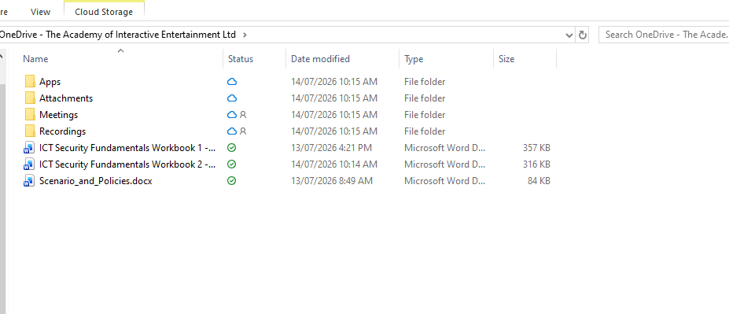
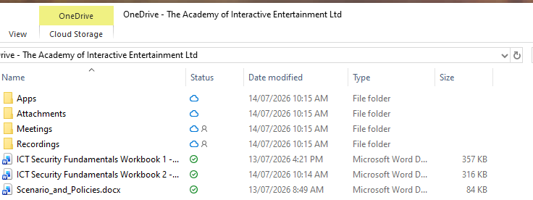

Task 2 – Two-Factor Authentication
Two factor authentication (2FA) is a way of strengthening sign-in security and making it harder for bad actors to gain access to your accounts.
In the box below describe what 2FA is and give an example of how it could be used to prevent someone logging into a website.
2FA is a system to ensure account security. It involves having a second form of authentication apart from an on-site password, normally on a different device, which is required for signing in. An example of 2FA in action is a malicious actor attempting to access a steam account, but cannot pass the 2FA app, which is used on a phone.

Task 3 – Strong Passwords
Passwords offer varying levels of security depending on their ‘strength’
In the box below describe the features that make a password ‘strong’ or ‘weak’ and explain why a ‘strong’ password is harder to guess than a ‘weak’ one.
A strong password is one that is not easy to memorise, long, and with lots of variety. A weak password is one that is common, short, easy to memorise, or linked to a person’s personality. Combining upper and lower case letters instead of just one or the other increases the number of letter combinations significantly, and using numbers and symbols makes it even harder to brute force a password.

WE STRONGLY RECOMMEND YOU USE STRONG PASSWORDS FOR ALL YOUR ONLINE SERVICES.

Assessment Submission Coversheet

Leaner Name: | William Norris
Trainer Name: | Jesse James Donlevy
Assessment Name: | ICT Security Fundamentals
Units Covered: | BSBWHS211 - Contribute to the health and safety of self and others  ICTICT213 - Use computer operating systems and hardware
Due Date: | 14/7/2026
Date of Submission: | Will be automatically recorded on Canvas
Assessment Work Location | Will be uploaded to Canvas (https://aie.instructure.com/) under the Game Engine Scripting Foundations module of this assessment’s name

Personal contribution
I answered all questions to my knowledge.

Declaration

By submitting this work under my name, I declare that my submission is my own work concerning plagiarism and does not violate any copyright laws. I have retained a copy of this assessment material that I can produce if requested.
☒ Tick to acknowledge you have read and agree with this declaration.

Name: William Norris

